PAPER TITLE PAPER TITLE PAPER TITLE PAPER TITLE PAPER TITLE PAPER TITLE PAPER TITLE
Name and Surname ¹⁾, Name and Surname ²⁾, etc.³⁾
¹⁾ Kielce University of Technology, Faculty of Mechatronics and Mechanical Engineering, Tysiąclecia Państwa Polskiego 3 Av., 25-314 Kielce, Poland, e-mail: login@tu.kielce.pl
²⁾ Rzeszow University of Technology, Faculty of Mechanical Engineering and Aeronautcs, Powstańców Warszawy 12 Av., 35-959 Rzeszów, Poland, e-mail: login@prz.edu.pl
³⁾ etc.

A constant rise in the number of combat operations involving air defence systems requires that the missile flight control methods be refined. Guidance to a moving target dictates that the missile should reach the target as fast as possible and meet the system performance requirements at the same time. The selection of the guidance method is an important factor as it has a profound effect on the likelihood of intercepting the target. Deviation of a missile motion from the ideal constraints is an error, which is used to formulate the guidance control rule. The special control algorithm proposed here is based on phase trajectories of control errors.
Due to the character of such interference, the impact on AAM dynamics, i.e. the flight path of the flying object, will be examined. There are many methods of modelling and analysing random phenomena, which include atmospheric interference. Negative effects of e.g. turbulence as an atmospheric phenomenon, were studied for various types of aircrafts: helicopters [1], guided bomb units, aeroplanes [2] and unmanned aircrafts [3]. An exemplary bomb assault on a ground moving target is shown in Fig. 1.
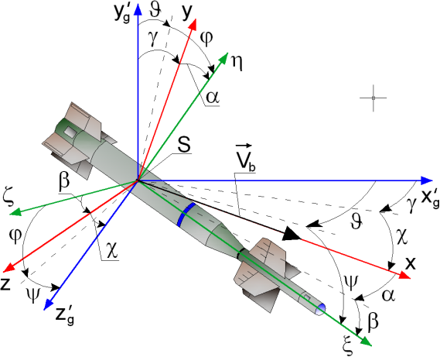
Fig.1. Example of bomb attack on target
It was assumed that the missile is a rigid block of constant mass which does not rotate around its own longitudinal axis. The motion of the considered AAM can be written in the form of the following equation:
$\frac{dV}{dt}=-g\sin{-{}_{x}V^{2}}$ (1)
where: V – missile velocity [m/s]; g – acceleration of gravity [m/s²]; λ_{x} – relative aerodynamic coefficients of aerodynamic forces and moments [1/m]; γ – achieved flight angle AAM [rad].

References
- Alexis K., Nikolakopoulos G., Tzes A., Switching model predictive attitude control for a quadrotor helicopter subject to atmospheric disturbances, “Control Engineering Practice”, 2011, 19(10), 1195-1207.
- Akmal H., Qu Y., Estimation of Wind Field Velocity and Aircraft States with an F-16 Lateral Guidance Control System, Proceeding of the 2015 IEEE International Conference on Information and Automation, China, 2015, pp. 2293-2298.
- Sydney N., Smyth B., Paley D. A., Dynamic Control of Autonomous Quadrotor Flight in an Estimated Wind Field, Proceeding of the 52nd IEEE Conference on Decision and Control, Italy, 2013, pp. 3609-3616

